GU Votes Campus Action Plan 2020-2021

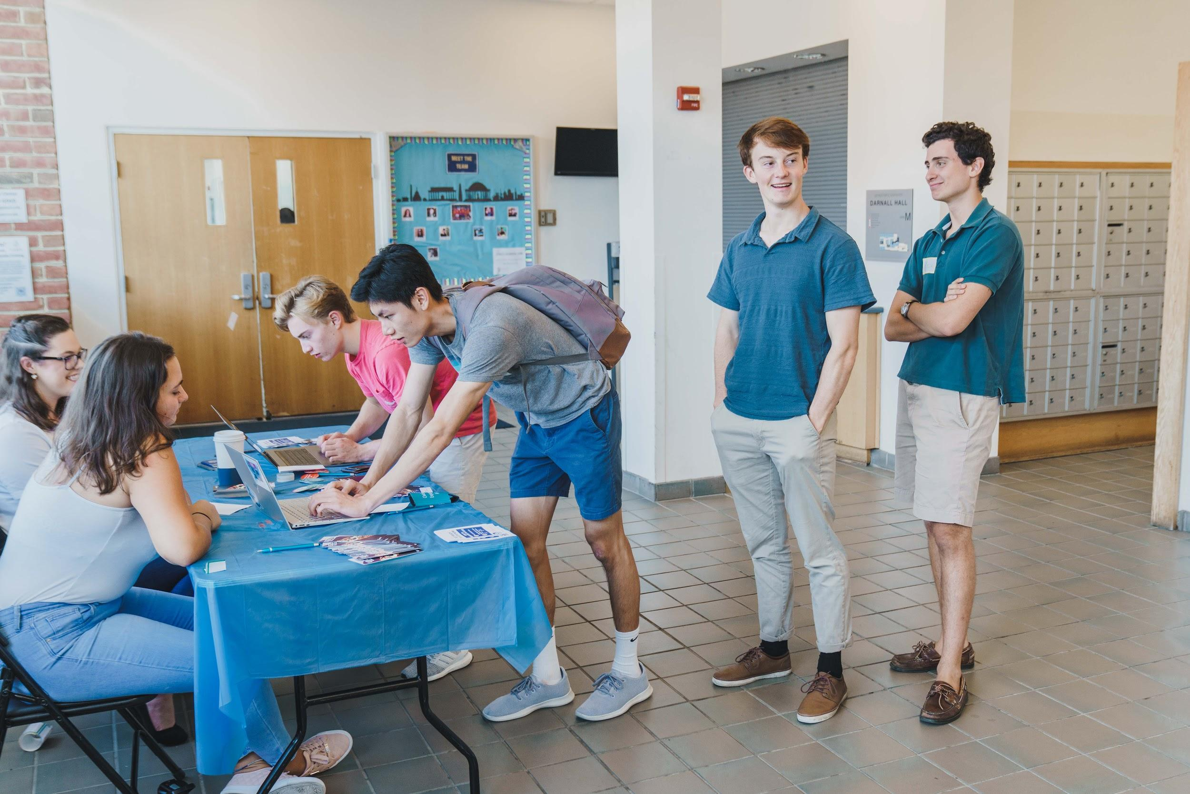
| Landscape

Describe the state of democratic engagement on your campus using the following categories or other categories relevant to your campus.

- NSLVE: In 2018, 84.8% of eligible Georgetown students were registered to vote. The overall voting rate among eligible students increased from 20.1% in 2014 to 49.0% in 2018, a 172% increase in voter participation. This was also 9.9 points above the national average of 39.1%. Also in 2018, 28.0% of student voters voted absentee, 14.5% by mail, and 37.8% in-person on election day.
- Partnerships: GU Votes is proud to partner with various clubs and institutions on campus. We have worked with Georgetown’s Office of Federal Relations to send campus-wide emails and the Office of Residential Living to coordinate our “Storm the Dorms” voter registration drive. For our Voter Dropbox Program, we’ve collaborated with the School of Foreign Service Dean’s Office, the Georgetown Scholarship Program, and student groups such as the Corp and La Casa Latina. We have also been building a “Georgetown Voting Coalition” of partner clubs and organizations.
- Resources: GU Votes is housed under the Georgetown Institute of Politics and Public Service (GU Politics), which provides staff and financial support for all of our efforts.
- Institutionalization: In 2019, Georgetown’s Vote Everywhere page was integrated into the MyAccess student portal, allowing Georgetown students to register to vote or request an absentee ballot when registering for classes. GU Votes is working to further institutionalize the voting process by connecting with New Student Orientation and academic deans.
- Programming: Our most successful programs have included the Voter Dropbox Program, campus-wide email campaigns, our annual “Storm the Dorms” voter registration drive, and working with other student groups to build the “Georgetown Voting Coalition.”
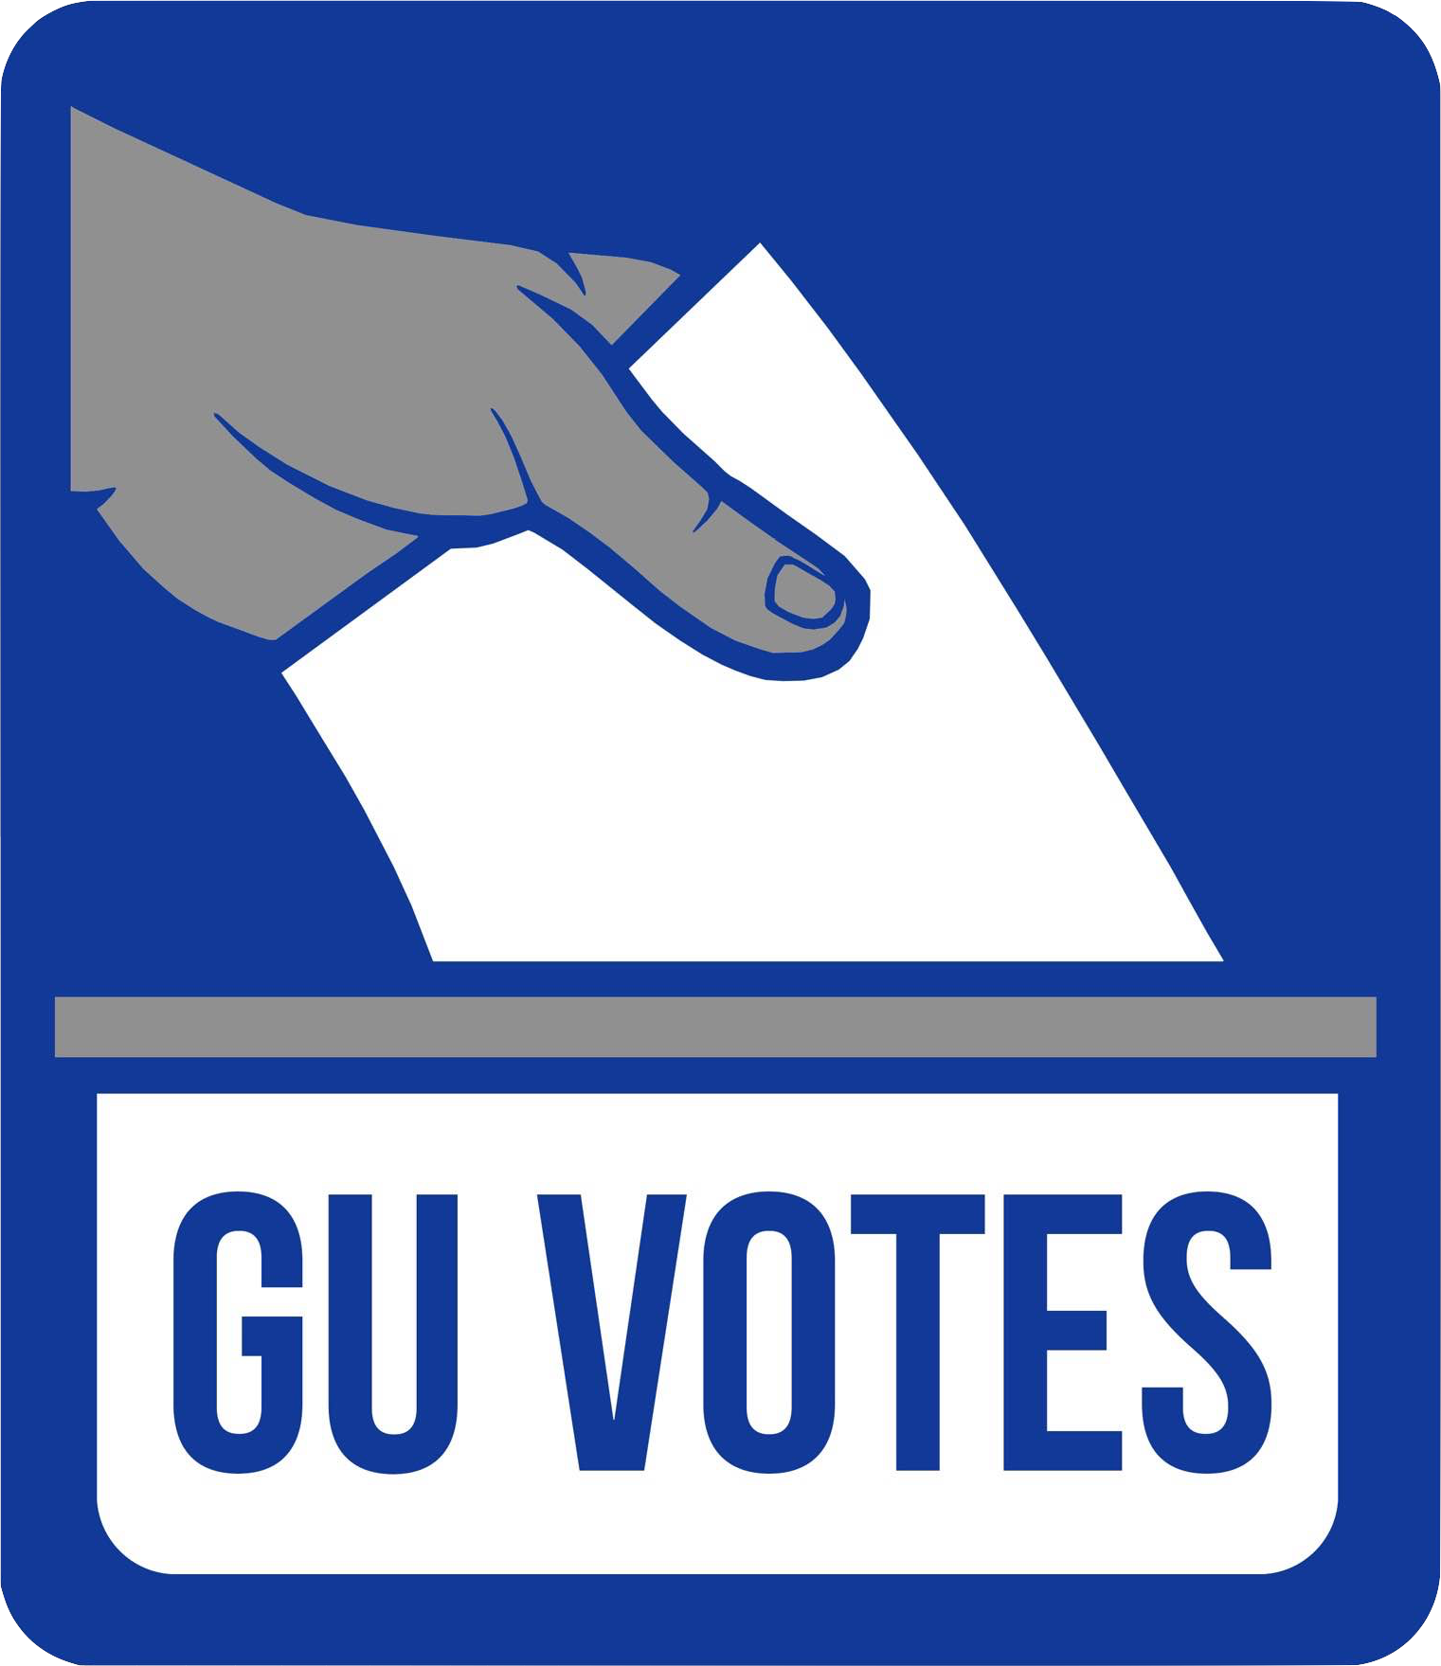
- Achievements, Challenges, and Opportunities: GU Votes has successfully expanded our partnerships and visibility on campus in the past year. Nevertheless, we must continue working to reach untapped areas such as STEM groups, athletics, and graduate students. We will also have to adapt our programming for an entirely virtual fall semester. To this end, we hope to expand our social media presence, engage in virtual classroom visits, and leverage GU Politics’ online programming.

| Goals

Create targets for progress within democratic, voter, and civic engagement on your campus and in your community. All goals should be S.M.A.R.T. (Specific, Measurable, Attainable, Relevant, and Time-bound).

- Long-term goals:
- Expand the influence of our civic engagement efforts beyond the main gates to the local Georgetown / DC community.
- Develop a meaningful dialogue with Hoya Hospitality to ensure that our voter registration efforts are reaching important members of our Georgetown community and campus staff.
- Remove additional barriers to voting and absentee ballot requests for Georgetown students.
- Increase percentage of total voter registration at Georgetown through engaging in meaningful dialogue, simplifying the voter registration and absentee ballot request process, and by conveying a moral urgency for all students and staff members to participate in our democracy.

- Short-term goals:
- Enable Georgetown students to vote safely and confidently amid the COVID-19 pandemic.
- Strengthen our relationship with campus partners in order to circulate meaningful content among cultural and political groups on campus.
- Integrate GU Votes into Georgetown orientation programs.
- Reach every Georgetown student and staff member through various mediums prior to the upcoming general election.
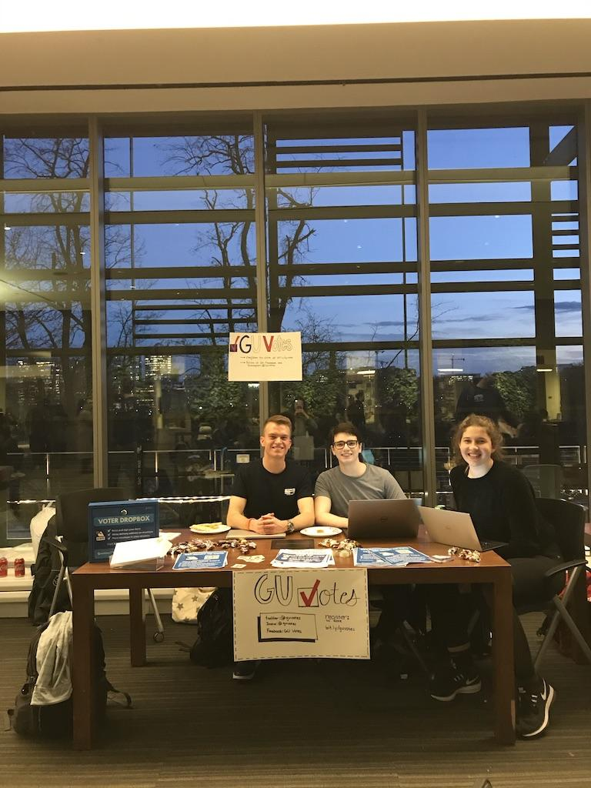
- Activate the Georgetown community through events that have the potential to inspire people to vote in the upcoming elections (including speaker forums and socials). This can be done using the GU Politics virtual forum throughout the duration of the COVID-19 pandemic.

| Strategy

Pursuing goals, especially long-term goals, can require multiple projects to achieve the desired outcome. Your strategies are the projects to achieve your goals, and the specific steps to carry out the strategies will be covered in the Tactics section.

- Long-term Goal Strategies:
- Expand the Georgetown Voting Coalition to include more campus groups and offices, including faculty and staff partners.
- Increase direct contact and communication with students about voter registration opportunities and the importance of civic engagement.
- Explore opportunities to work more directly with Georgetown staff and DC groups.

- Short-term Goal Strategies:
- Implement a pop-up/banner with voting resources on the student Canvas website to reach the entire student population.
- Work with deans of Georgetown undergraduate schools to encourage faculty to include voter engagement resources in newsletters and academic advising.
- Engage in virtual classroom visits to present to students about GU Votes and voter registration.
- Connect with graduate school deans and student groups.
- Secure funding for a direct mail campaign or increased digital outreach to students living off-campus for the fall semester.
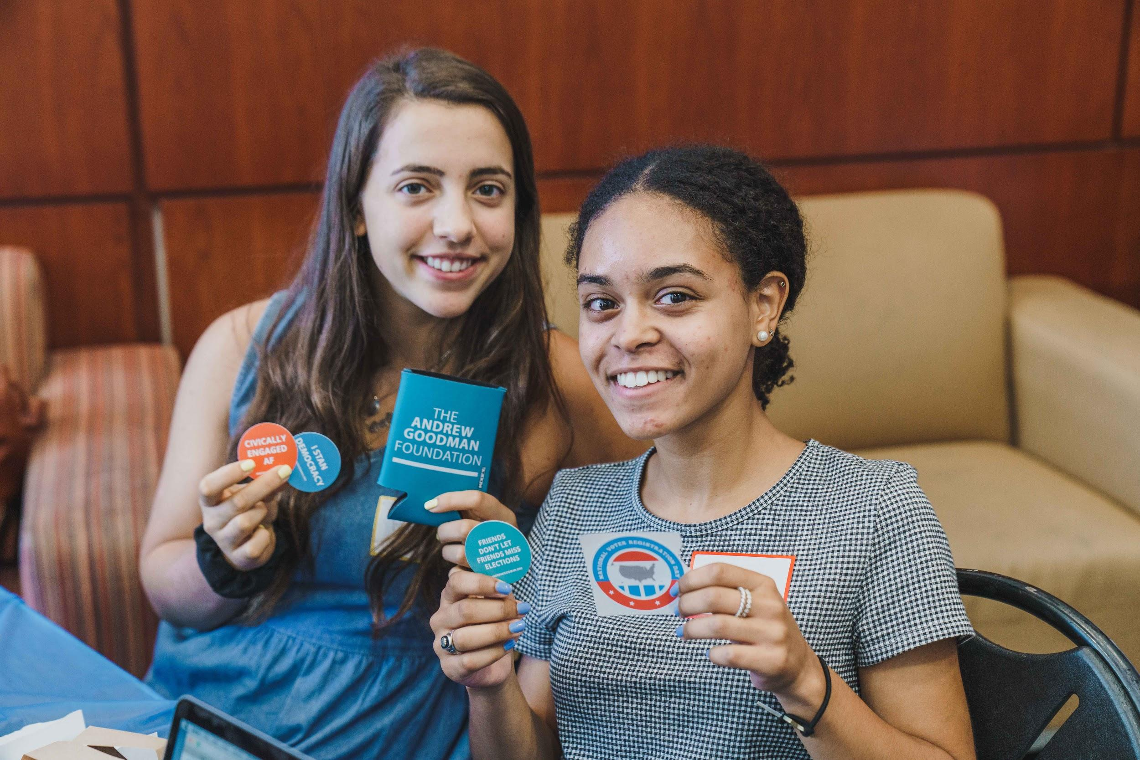

| Tactics

All of the actions your Campus Team takes related to the Andrew Goodman Vote Everywhere program are tactics used to complete a strategy and achieve a goal.

- Events:
- Work with GU Politics to integrate voting reminders and opportunities to request more information from GU Votes when registering for their online events
- Host speaker forum on topic related to civic engagement
- Freshmen voter registration competition initiated by University of Chicago
- NVRD virtual programming

- Actions:
- Reach out to The Hoya and The Voice for coverage of voter engagement efforts
- Work with the Georgetown Voting Coalition to share voting reminders via student groups
- Direct mail campaign to student home addresses

- Meetings:
- New Student Orientation leaders
- Student group partners for the Georgetown Voting Coalition (i.e. the Corp, GUCD, GUCR, La Casa Latina, athletic teams)
- Virtual classroom visits
- Deans of undergraduate schools
- Graduate school contacts

- Digital Organizing:
- State-specific emails sent to every student before the general election
- Social media campaigns including #WhyIVote with videos from well-known alumni and a sharable template for students
- Increase use of Vote Everywhere texting platform
- Voting channel in GU Politics Slack group
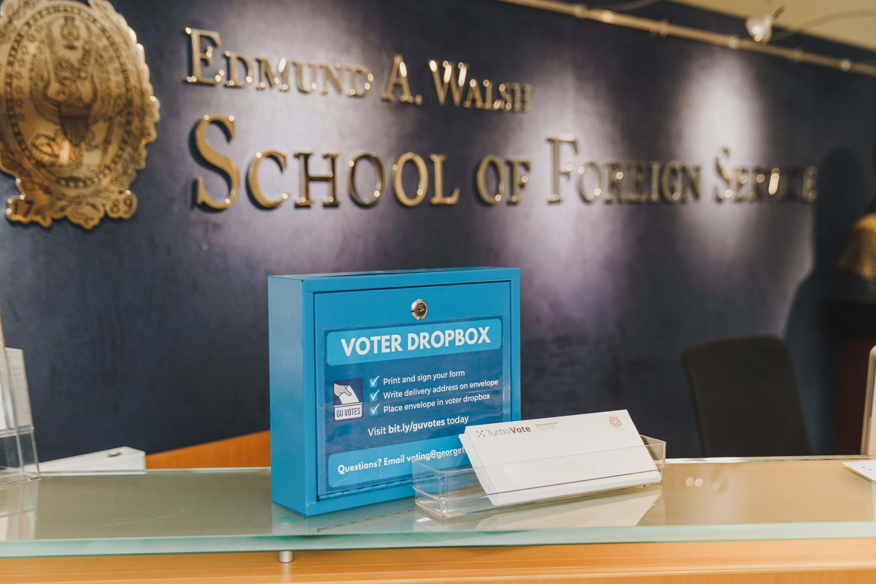

| Timeline

Focusing on the 2020-2021 academic year, schedule your tactics by semester.

- Fall 2020:
August Integration into New Student Orientation
Reach out to campus partners
Virtual classroom visits
Initiate voter registration competition with UChicago
September Banner integration on Canvas (whole month)
State-specific emails sent by Office of Federal Relations
Why I Vote Campaign (whole month)
Potential direct mail campaign
NVRD virtual programming (9/22)
October Voting event
Social media campaign on registration/absentee ballot dates
Continued engagement with GU Politics events and Georgetown Voting Coalition groups
November Election Day Event
Absentee ballot support
December Reflections on election strategy

- Spring 2021:
January Reflections on 2020 elections and events
Brainstorming programming/speakers for 2021
February Host voting event/speaker
March Host voting event/speaker
April Strategize for 2021/22 school year
Review NSLVE Report (if released by then)
May Strategize for 2021/22 school year

JJanu
| Monitoring and Evaluation
To track progress toward achieving goals through strategies and tactics, ensure regular communication with stakeholders and track quantitative and qualitative data.

- Meetings:
- Weekly core team meetings
- Biweekly meetings with program manager
- Monthly (at least) meetings with campus champion (Carly)

- Event Reports:
- Use of AGF program tracker after events/programming
- Using data from our bit.ly and Vote.org

- NSLVE:
- Designate a team meeting to going over data and identifying key data points and trends
- Create a graphic to demonstrate changes in the data between 2016-2020
- Target which demographics on campus are the least likely to be registered to vote

- Research:
- Sending out survey to our mailing list/GU Politics mailing list before 2020 election about what programming people desire/would find the most helpful
- Sending out survey to our mailing list/GU Politics mailing list after 2020 election about visibility and effectiveness of efforts
